

IMAGING SYSTEM
VERIFIER
USER MANUAL

Version 3.0

April 2007

Department of Veterans Affairs
System Design and Development
VistA Imaging

Revision Table
Date | Patch | Description
June 2005 | Patch 20 | Created draft for new Verifier User Manual.
Jan 2006 | Patch 20 | Work Product Review Modifications.
Mar 2006 | Patch 20 | Additional Work Product Review Modifications.
Jan 2007 | Patch 81 | Added error description for missing Acquisition Site
Apr 2007 | Patch 81 | Added information on the NO_ARCHIVE log

Preface
The purpose of this manual is to provide users with instructions on implementing the VistA Imaging Verifier V. 3.0 software and assist them in interpreting the output HTML files produced by the Verifier. It includes explanations of the options and controls available on the GUI of the VistA Imaging Verifier.
This manual is also available at: http://vaww.va.gov/imaging

Table of Contents
Preface iii
Chapter 1 Introduction 1
1.1 Description of Verifier 1
1.1.1 System Requirements 1
1.2 Maintenance Operations 1
▪ Routine scanning of newly acquired images 1
▪ Periodic maintenance of the VistA Imaging system 1
▪ Large Image Share population events 1
▪ Image share or Jukebox outages 2
1.3 Offline Platters 2
Chapter 2 Verifier Operations 3
2.1 Verifier Setup 3
2.2 Verifier Processing 3
2.2.1 Scan Initialization 4
2.2.2 Scan Processing 5
2.2.2.1 VistA Imaging Shares 5
2.2.2.2 Scan Controls 6
2.2.2.3 Scan Summary 7
2.2.2.4 Jukebox Shares 8
2.2.2.5 Activities 9
2.2.3 Integrity Checks 10
2.2.3.1 File Integrity Checks 11
2.2.3.2 Patient Integrity Checks 11
2.2.3.3 Text File Integrity Checks 11
2.2.4 Aggregate Functionality 12
2.2.5 Abstract Creation 13
2.3 Verifier Scan Completion 13
2.3.1 Verifier Summary 13
2.3.2 Output HTML Files 16
2.3.2.1 Certed.html 17
2.3.2.2 Scan.html 18
2.3.2.3 NoArchive.html 19
2.3.2.4 Scanerror.html 21
2.3.2.5 DFNError.html 23
Appendix 25
Appendix A Verifier Start/Run Errors 25
Appendix B Output HTML Messages 26
Appendix C Patient Integrity Messages 28
Appendix D Text File Samples (with integrity problems) 30
Glossary 34

Introduction

Description of Verifier
The Verifier is used to identify, and in some cases correct, inconsistencies within the VistA database, as well as identify incorrect image file locations in VistA. It detects mismatches between image file contents and the VistA database. The Verifier performs 14 patient integrity checks (as described in Appendix C). It sets/clears invalid file location pointers in the database and checks for mismatches between specific fields in the text files and the database. In addition, the Verifier recreates missing file types, when possible. Because of the constant movement of image-related data, it is important that the Verifier be exercised on a regular basis.
Each day images are saved on the VistA Imaging RAID and jukebox. References are set in patient reports for these images in order to support archiving and viewing. In addition, files are removed from the RAID to free up storage space and at some point are recalled from the jukebox. All of these operations result in changes to the database. Inconsistencies in the database can result because of discrepancies between files that interact, manual corrections, network anomalies, power outages, hardware failures and incomplete database updates.

System Requirements
The Verifier client software can be installed on VistA file servers with at least 1GB memory and sufficient disk space to contain the HTML log files. The Verifier should be run on the Image servers. The server must be set up to have a connection to VistA.

Maintenance Operations
Verifier scans can be run any time of the day as there is minimal impact on VistA. They should be run based on the following events:

Routine scanning of newly acquired images
The Verifier should be run every 1 or 2 weeks to verify new entries in the IMAGE file (#2005). In some cases, if images are missing they can be resent from the modality.

Periodic maintenance of the VistA Imaging system
The Verifier should be run several times each year to verify the entire range of Image Internal Entry Number (IENs) (#2005). During the year, many files will be retrieved from the jukebox and pointers updated in the database. This will insure that files on the RAID and the Jukebox can be accurately located.

Large Image Share population events
The Verifier should be run over the range of Image (IENs) that were copied back to the Image shares from the jukebox. There may be occasions where files were not copied and incorrect file pointers set in the database with this large volume of files being moved to the RAID.

Image share or Jukebox outages
The Verifier should be run after the resolution of any event that interrupted the flow of images to the Jukebox. The Queue Processor will attempt to copy files to the jukebox 3 times. At that point it will indicate failure and begin processing the next entry in the queue. Note that these files ONLY reside on the Image shares and therefore MUST be copied promptly to the jukebox using the Verifier.

Offline Platters
When the jukebox is physically full and space is needed to add additional platters, the OFFLINE IMAGE utility MUST be used (See Chapter 9 “Jukebox Archive” section of the Imaging System Technical Manual) prior to physically removing the platters. This utility will mark the IENs as being archived and the Verifier will skip these while processing.

Verifier Operations
This chapter describes the setup, operation and scan results of the Verifier.

Verifier Setup
All setup is done on the Verifier window (Figure 1) in the Scope area. The user can select either a range of Image IENs or all IENs.
In the Check Image Text window, the Check option can be selected. The Verifier will compare specific fields in the text files with data contained in the associated Image file records in VistA. When this option is selected, processing time will increase by a moderate amount. It is not necessary to select this option each time the Verifier is run, but it should be run periodically. (Note: Suggested times are right before a Purge or when several years of images are pulled from the jukebox to populate the Image shares.)
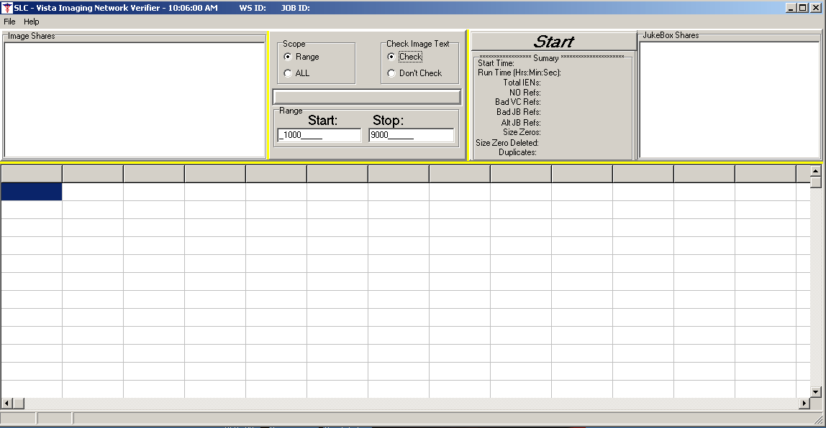
Figure 1 Verifier window

Verifier Processing
The Verifier window (see Figure 3) will show the processing steps for each Image IEN selected in the Scope section. When the IEN range includes files that have been saved in a flat file structure, there will be a noticeable increase in the time it takes to complete the scan. Processing within the Verifier window cannot be interrupted as in the Queue Processor (START/STOP) but when the Verifier completes, the user can select a new set of IENs in the SCOPE without terminating the Verifier. Copies of the processing steps are contained in the HTML log files. A list of potential errors that might occur while processing is contained in Appendix A.

Scan Initialization
When a scan is started, the Shares Off-line window (Figure 2) will appear. It displays all the image and jukebox shares in the NETWORK LOCATION file (#2005.2) that have an OPERATIONAL STATUS of OFFLINE. Users must acknowledge that those shares will not be processed. To set them ONLINE, they must be changed within the Queue Processor Network Location window. Table 1 describes each of the columns.
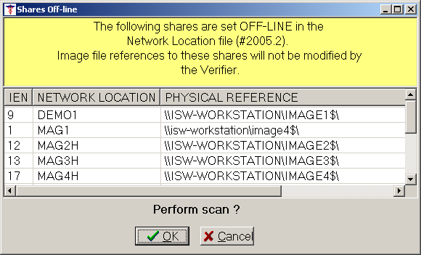
Figure 2 Shares Off-line

IEN | The NETWORK LOCATION file (#2005.2) entry number.
NETWORK LOCATION | The name of the entry in the NETWORK LOCATION file (#2005.2).
PHYSICAL REFERENCE | Network path of the Imaging share.
OPERATIONAL STATUS | ONLINE/OFFLINE  If ONLINE, image references to this share will be processed.  If OFFLINE, the image references to this share will not be processed.
Table 1 Shares Off-line

Scan Processing
An example of the main window as it would look while scan processing is in progress is shown in Figure 3.
VistA Cache Shares

Scan Controls

Jukebox Shares

Scan Summary

Activities

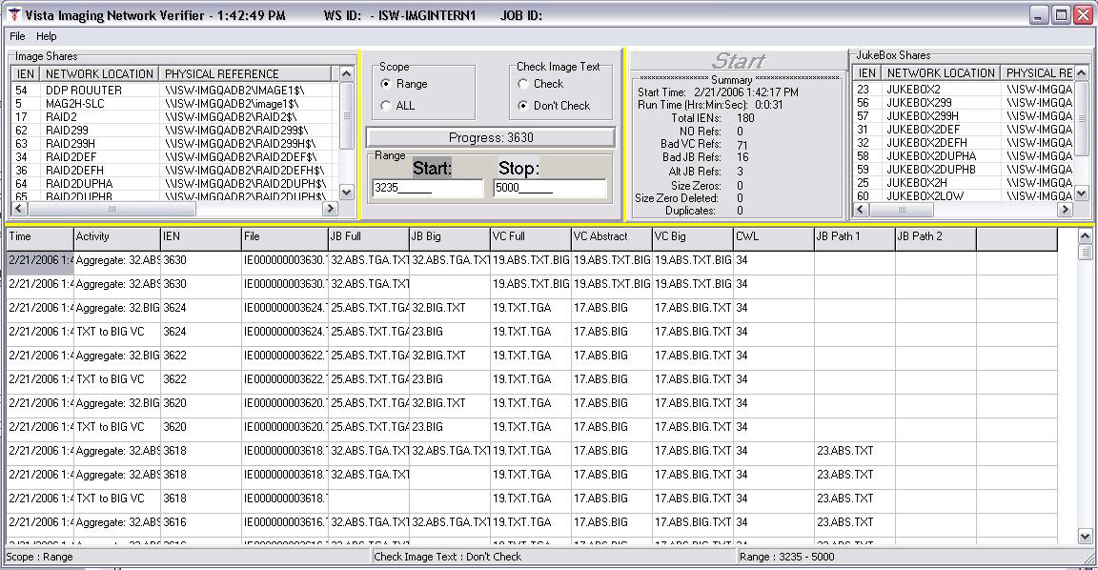
Figure 3 Scan Processing

VistA Imaging Shares
The Image Shares window (Figure 4) lists the magnetic shares and information about each share. This window can only be viewed or resized when the Verifier completes. Table 2 describes each of the columns.
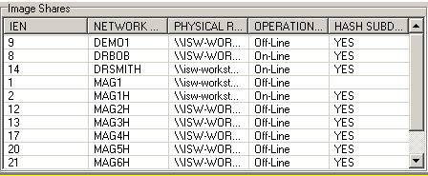
Figure 4 VistA Imaging Shares

IEN | The NETWORK LOCATION file (#2005.2) entry number.
NETWORK LOCATION | The name of the entry in the NETWORK LOCATION file (#2005.2).
PHYSICAL REFERENCE | Network path of the Imaging share.
OPERATIONAL STATUS | ONLINE/OFFLINE  If ONLINE, image references to this share will be processed.  If OFFLINE, the image references to this share will not be processed.
HASH SUBDIRECTORY | YES/NO  If YES, directory hashing is used. If NO, image files are stored in the top level folder in a flat file structure.
Table 2 VistA Imaging Shares

Scan Controls
The input parameters for controlling what IMAGE file (#2005) entries are processed and the type of processing is set in the Scan Controls window (Figure 5). Table 3 describes each of the field entries.
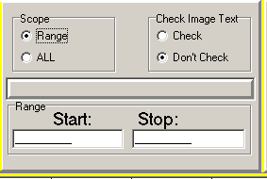
Figure 5 Scan Controls

Table 3 describes each of the field entries.
Scope | Determines if all IMAGE file (#2005) entries or a range of entries will be processed.
Check Image Text | Information in specific fields in the text files on the Image shares are compared to the matching fields in VistA.
Range | Enables the selection of a range of IENs to be scanned.
Table 3 Scan Controls

Scan Summary
The Scan Summary Window (Figure 6) displays the results of the Verifier scan and is also included in the Scan.html file. Table 4 describes each of the fields.
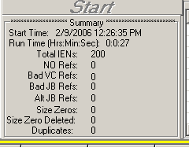
Figure 6 Scan Summary

Start Time | Date and time this Verifier scan was started.
Run Time | Total elapsed time the Verifier ran.
Total IENs | Number of IMAGE file (#2005) entries processed in this scan.
No Refs | Number of missing IMAGE file (#2005) records.
Bad VC Refs | Number of ABS/FULL/BIG IMAGE file (#2005) pointers cleared (DISK & VOLUME, MAGNETIC/DISK & VOLUME, ABSTRACT/BIG MAGNETIC PATH).
Bad JB Refs | Number of jukebox IMAGE file (#2005) pointers cleared/set. (DISK & VOLUME, WORM/BIG JUKEBOX PATH).
Alt JB Refs | Number of additional jukebox shares found in addition to the primary.
Size Zeros | Number of files (Image and jukebox shares) found with zero length.
Size Zero Deleted | Number of files deleted that had a size of zero. Only Image share files will be deleted.
Duplicates | Number of Image entries that are duplicated in the IMAGE file (#2005) and the IMAGE AUDIT file (#2005.1). These images are un-viewable because the image files themselves have the same file names and therefore have ambiguous patient and procedure references.
Table 4 Scan Summary

Jukebox Shares
This window is populated at the beginning of a scan. All jukebox shares are listed in the Jukebox Shares window (Figure 7). This window displays status information on each of the shares that are defined in the NETWORK LOCATION file (#2005.2). This window can only be viewed or resized when the Verifier completes. Table 5 describes each column in the Jukebox Shares window.
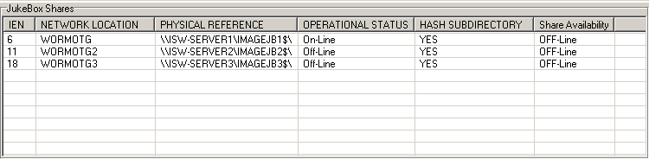
Figure 7 Jukebox Shares

Table 5 Jukebox Shares
IEN | The NETWORK LOCATION file (#2005.2) entry number for the jukebox.
NETWORK LOCATION | The name of the entry in the NETWORK LOCATION file (#2005.2).
PHYSICAL REFERENCE | Network path of jukebox share.
OPERATIONAL STATUS | ONLINE/OFFLINE  If ONLINE, image references to this share will be processed.  If OFFLINE, the image references to this share will not be processed.
HASH SUBDIRECTORY | YES/NO  If YES, directory hashing is used. If NO, image files are stored in the top level folder in a flat file structure.
SHARE AVAILABILITY | ONLINE/OFFLINE  The software can access the share on the network.

Activities
The Activities window (Figure 8) shows the current processing that is done for each Image IEN. The activities are all saved in the output HTML files and each column is described in Table 6.
Figure 8 Activities Window

Time | Actual time when the IMAGE file (#2005) was processed.
Activity | Description of action taken.
IEN | IMAGE file (#2005) entry currently being processed.
File | Filename (FILEREF) in the current IMAGE file (#2005) record being processed.
JB Full | NETWORK LOCATION file (#2005.2) of jukebox where Full image is located. Other extensions will be listed here except the BIG file. (It is listed in the JB Big column.)
JB Big | NETWORK LOCATION file (#2005.2) of jukebox where BIG image is located. The extensions of all files on the jukebox will be listed.
VC Full | NETWORK LOCATION file (#2005.2) of image share where FULL image is located. (Other file extensions that are on this share are listed, also.)
VC Abstract | NETWORK LOCATION file (#2005.2) of image share where abstract image is located. (Other file extensions that are on this share are listed, also.)
VC Big | NETWORK LOCATION file (#2005.2) of image share where the BIG image is located.
CWL | Image share that is the current write location. This will change automatically if the AUTO WRITE LOCATION UPDATE option is selected. (The check is done after 100 writes to the share or 20 minutes has expired since the last check.)
JB Path 1 | NETWORK LOCATION file (#2005.2) of first alternate jukebox.
JB Path 2 | NETWORK LOCATION file (#2005.2) of second alternate jukebox.
Table 6 Activities

Integrity Checks
The Verifier steps through each of the IENs within the range looking for specific types of problems including:
- File integrity— File location references in the IMAGE file (#2005) are physically checked to determine the existence of the file(s) on their assigned Imaging share(s) and jukebox. If any file (excluding TXT) is missing from the Image shares, the pointer will be cleared in the IMAGE file (#2005) record. If all files are missing on the current jukebox or alternate jukeboxes, the jukebox pointer will be cleared. The Verifier will set the jukebox pointer if any of the files in the set are found on the current or alternate jukebox. The Verifier will also look at the IMAGE AUDIT file (#2005.1) to insure the file set exists at the location(s) specified in this file.
- Patient integrity—Patient-related values in the IMAGE file (#2005) are checked for consistency within the group Image entries and the associated report files. See Appendix C for a list of the status conditions that are checked.
- Check Image Text— Specific fields in the text files on the Image shares are checked against the information in VistA. See Appendix D for samples.
The HTML output files will contain a record of all processing done including problems found during the scan processing. Some problems will be fixed during the scan. Others will require the Imaging Coordinator/National Help Desk to correct --such as:
- Missing files that could not be created from existing files. These must be restored from the tape backups.
- Patient integrity issues to include wrong patient images in radiology reports, missing group parent and missing group objects.
- Specific information in text files that does not match VistA.

File Integrity Checks
For each IMAGE file (#2005) processed, the Verifier reads the pointer locations and determines the existence of the FULL, Abstract, BIG (if available) and TEXT files on the Image shares and jukebox.
If files are found on the image shares that are not on any jukebox share, the files are copied to the current jukebox directly and the IMAGE file (#2005) references are updated. The Verifier will copy the associated text file to each Image share that contains the FULL and BIG file if it exists, as well as the jukebox location.
The file size is checked on the Image share to see if it is non-zero. Image share files of zero size are deleted and the IMAGE file (#2005) reference is updated. Files of size zero found on the Jukebox shares are NOT deleted.
If no TGA file exists but a BIG file does exist, then a TGA file is created using the BIG file as the source. Similarly, if no abstract file exists but a FULL file is present, then an abstract file is created from this FULL/BIG file.

Patient Integrity Checks
The Verifier also performs a patient integrity check during the scanning. The Help file (Help|DFN Help) describes the different Patient Integrity conditions, as well as Appendix C in this manual. Any problems found are reported in the Site Quality Assurance Findings report and in the DFNError.html file.

Text File Integrity Checks
When the Check option is selected in the Check Image Text window, the Verifier will compare specific fields in the text file with those in the associated IMAGE file (#2005) record in VistA. (See Appendix D for samples of the text files and the conditions that are tested.) The following is a list of problems that the Verifier detects. Included in the list is a suggested way of correcting these problems.
- Text file is binary or unreadable.
  - Correction- Copy the version from the jukebox or get a copy from the backup tapes
- Text file is ASCII but has unprintable characters or truncated.
  - Correction- Copy the version from the jukebox or get a copy from the backup tapes
- Patients ID (SSN) field in the text file does not match that in VistA.
  - Correction- Contact the National Help Desk.

The following fields are in the DICOM DATA block (lower section of the text file). These fields are generated by the modality and should not be altered.

- SOP Instance UID field (DICOM- 0008,0018) in the text file does not match the one in VistA. (“PACS” node – PACS UID field #60 in the IMAGE file (#2005) on the IMAGE IEN.)
  - Correction- Most likely the text file has the correct UID. Make the correction in VistA (PACS UID field #60 in the IMAGE file (#2005)) to match the DICOM field (0008,0018).
- Study Instance UID field (DICOM- 0020,000D) in the text file does not match the one in VistA. (“PACS” node – PACS UID field #60 on the PARENT IEN.)
  - Correction- Most likely the text file has the correct UID. Make the correction in VistA (PACS UID field #60 in the IMAGE file (#2005)) to match the DICOM field (0020,000D).
- SOP (DICOM- 0008,0018) and/or Study Instance UID (DICOM- 0020,000D) are/is blank in the text file.
  - Correction- If these fields are blank and the image is stored in VistA in TGA format, then this crucial information is lost and it will be impossible to reconstitute the DICOM image. Call the National Help Desk.
- Patient ID (SSN) in the top section (DATA1) of the text file does not match the DICOM field (0010,0020) in the bottom section (DICOM DATA).
  - Correction- This file has already been corrected and needs no further correction if the Patients ID field (SSN) in the top section (DATA1) matches VistA.

Aggregate Functionality
Currently there is only one pointer in VistA for the different file types that are saved on the jukebox. A problem arises when file types spread across two jukeboxes or when a full or abstract file does not exist on an alternate jukebox (which typically is no longer available for writing) and needs to be created and stored at the current jukebox location. The aggregate function does the processing to get all the file types onto the current jukebox if the conditions above exist for a particular Image file IEN.

Abstract Creation
The Verifier will automatically create abstracts from certain file types. The abstracts are created on the Image shares and then copied to the jukebox. In cases where the FULL or BIG file is on an alternate jukebox, the aggregate function will be applied to insure the newly created abstract resides on the current jukebox with the FULL/BIG/TXT file. The Verifier will create abstracts for the following type of file extensions:
▪ 756 ▪ ABS ▪ BIG ▪ BMT ▪ BW
▪ DCM ▪ JPG ▪ PAC ▪ TGA ▪ TIF

Verifier Scan Completion
When processing is completed, the Verifier Summary window (Figure 8) will be displayed. The HTML log files are located in \Program Files\VistA\Imaging\BackProc\Log\Verifier folder. These files can be opened with the web browser as well as imported into an Excel spreadsheet.

Verifier Summary
The Verifier Summary window (Figure 9) opens automatically after a scan is completed. Information about the image and jukebox shares as well as statistics on the completed Verifier scan is shown in this window. The contents of this window are not saved when it is closed. To retain the information in this window, use the File > Print or the File > Save option.
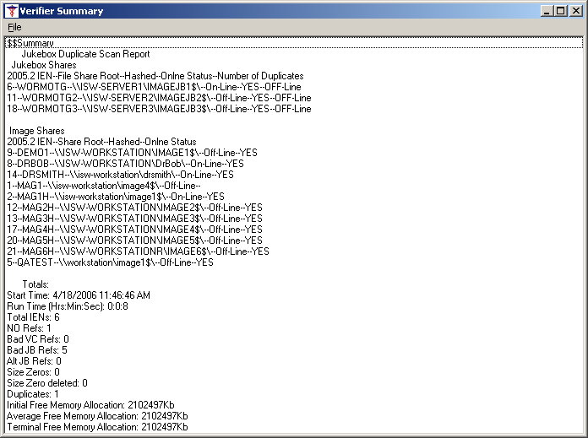
Figure 9 Verifier Summary

Summary Section:
The Summary section in Figure 9 lists all the image servers and jukeboxes that are in the NETWORK LOCATION file (#2005.2). It shows status information for each of the shares. Table 7 describes each of the fields.
(Sample)
6--WORMOTG--\\ISW-SERVER1\IMAGEJB1$\--On-Line--YES--OFF-Line
1 | 2 | 3 | 4 | 5 | 6 |
1 | The NETWORK LOCATION file (#2005.2).
2 | The name of the entry in the NETWORK LOCATION file (#2005.2).
3 | Physical Reference of the share in UNC format.
4 | Operational Status - ONLINE/OFFLINE  If ONLINE, image references to this share will be processed.  If OFFLINE, the image references to this share will not be processed.
5 | Hashed subdirectories (YES/NO) -- If YES, directory hashing is used. If NO, image files are stored in the top level folder in a flat file structure.
6 | Share availability – OFFLINE/ONLINE -- The Verifier can “see” the share on the network.
Table 7 Summary

Totals Section:
The Totals section in Figure 9 lists scan statistics and counts for any file integrity issues found during the scan. Table 8 describes each of the entries.
Start Time | The time of day the scan was started.
Run Time | The amount of time it took the scan to run.
Total IENs | The number of IMAGE file (#2005) entries scanned. (Only single and child entries are counted; group (parent) entries are not counted.)
NO Refs | The number of IMAGE file (#2005) entries with no Image share or jukebox location references.
Bad VC Refs | The number of IMAGE file (#2005) entries with Image share references that could not be matched to an actual file stored on an image share.
Bad JB Refs | The number of IMAGE file (#2005) entries with jukebox references that could not be matched to an actual file stored on a jukebox.
Alt JB Refs | The number of files found on multiple jukebox share locations is listed. (These are copied to the current jukebox share using the aggregate function).
Size Zeros | The number of zero length files found on the Image shares and jukebox shares.
Size Zeros Deleted | The number of zero length files deleted from the Image shares.
Table 8 Totals

Output HTML Files
The Verifier creates a new set of HTML files each day and each time the Verifier is run. HTML files are stored in the \Program Files\VistA\Imaging\BackProc\Log\Verifier folder. These files have the year-month-day and sequence number imbedded in the file name. The highest sequence number is the latest for the day. The files should be kept for historical reasons and added to the backup storage to safeguard the files. (See “Appendix B Backups” section of the Installation Guide). The files are never deleted and storage space maintenance is left to the user. The output HTML files can be accessed through the File | Open Log menu option or can be viewed with the internet browser. In addition, they can be imported into an Excel spreadsheet.
In addition to the primary files, the Verifier produces the following sequenced HTML output files:
Certedddmmyy_seq#.html: Lists entries with no file integrity problems.
Scanddmmyy_seq#.html: Lists entries with potential file integrity problems. The successful/unsuccessful attempts at correcting a problem are listed.
NoArchiveddmmyy_seq#.html: Lists files that are missing from the Jukebox.
Scanerrorddmmyy_seq#.html: Lists file integrity problems that the Verifier was not able to resolve.
DFNErrorddmmyy_seq#.html (Image Integrity Check Report): Lists patient integrity problems.

Certed.html
The Certed.html log (Figure 10) shows all IENs that had the correct pointer settings in VistA or the appropriate action was taken to create the missing file and set the appropriate pointer. No action is required on any of these entries. The descriptions for the columns are in Table 9.
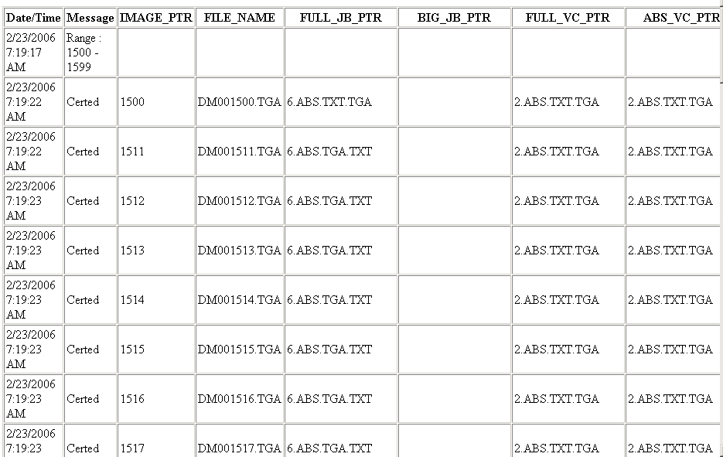
Figure 10 Certed.html

Date/Time | Actual time when the IMAGE file (#2005) was processed.
Message | Description of action taken (see Appendix B)
IMAGE_PTR | IMAGE file (#2005) currently being processed.
FILE_NAME | Filename (FILEREF) in the current IMAGE file (#2005) record being processed.
FULL_JB_PTR | NETWORK LOCATION file (#2005.2) of jukebox where FULL image is located. Other extensions will be listed here except the BIG file. (It is listed in the JB Big column.)
BIG_JB_PTR | NETWORK LOCATION file (#2005.2) of jukebox where BIG image is located. The extensions of all files on the jukebox will be listed.
FULL_VC_PTR | NETWORK LOCATION file (#2005.2) of image share where FULL image is located. (Other file extensions that are on this share are listed, also.)
ABS_VC_PTR | NETWORK LOCATION file (#2005.2) of image share where abstract image is located. (Other file extensions that are on this share are listed, also.)
BIG_VC_PTR | NETWORK LOCATION file (#2005.2) of image share where the BIG image is located.
Current_Write_PTR | Image share that is the current write location. This will change automatically if the AUTO WRITE LOCATION UPDATE option is selected. (The check is done after 100 writes to the share or 20 minutes has expired since the last check.)
Table 9 Certed.html

Scan.html
The Scan.html (Figure 11) file records the operational events that take place to correct a particular problem. No action is required on these entries. They are used to determine if and how the Verifier corrected the faulty condition. The IENs that the Verifier could not fix are listed in the Scanerror.html log file. The descriptions for the columns are in Table 10. (See Appendix B for the complete list of Messages.)
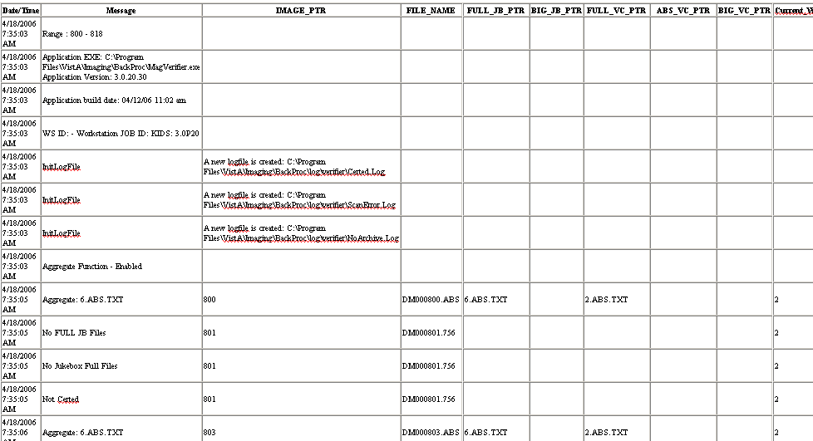
Summary of version/dates/log file names

Figure 11 Scan.html

Date/Time | Actual time when the IMAGE file (#2005) was processed.
Message | Description of action taken.
IMAGE_PTR | IMAGE file (#2005) currently being processed.
FILE_NAME | Filename (FILEREF) in the current IMAGE file (#2005) record being processed.
FULL_JB_PTR | NETWORK LOCATION file (#2005.2) of jukebox where FULL image is located. Other extensions will be listed here except the BIG file. (It is listed in the JB BIG column.)
BIG_JB_PTR | NETWORK LOCATION file (#2005.2) of jukebox where BIG image is located. The extensions of all files on the jukebox will be listed.
FULL_VC_PTR | NETWORK LOCATION file (#2005.2) of image share where FULL image is located. (Other file extensions that are on this share are listed, also.)
ABS_VC_PTR | NETWORK LOCATION file (#2005.2) of image share where abstract image is located. (Other file extensions that are on this share are listed, also.)
BIG_VC_PTR | NETWORK LOCATION file (#2005.2) of image share where the BIG image is located.
Current_Write_PTR | Image share that is the current write location. This will change automatically if the AUTO WRITE LOCATION UPDATE option is selected. (The check is done after 100 writes to the share or 20 minutes has expired since the last check.)
Table 10 Scan.html

2.3.2.3 NoArchive.html
The NoArchive.html file (Figure 12) contains image file names that are missing on the jukebox and could not be created from existing files and/or could not be found on the RAID (See Table 11 for an explanation of the columns). The Verifier examines both the Image file (#2005) and the Image Audit file (#2005.1) for missing files. The 2005.1 column depicts those missing files that have been deleted and the Image file (#2005) record has been moved to the Image Audit file (#2005.1). An attempt should be made to correct any problems that are listed in this log file. These files must be restored using one of the following methods:
- Restore from backup tape(s).
- Resend from the gateway.
- Re-capture on the Capture workstation.
- File restore from platter on jukebox.
- If the missing file cannot be located, the Patient ID information and provided information for these missing field(s) should be sent to the hospital staff person(s) who need this information.
If the missing file cannot be located, the Patient ID information and provided information for these missing field(s) should be sent to the hospital staff person(s) who need this information.
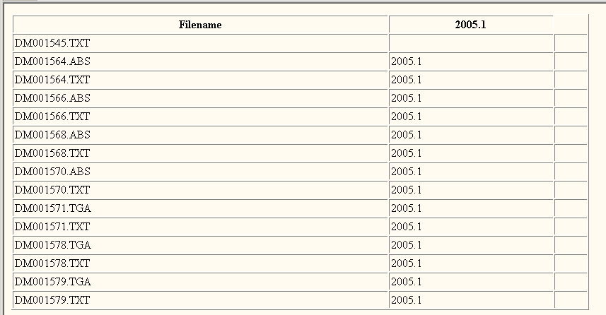
Figure 12 No_Archive.html

Filename | Name of the missing file
2005.1 | If the column contains “2005.1”, then the Image has been deleted and the image information is in the Image Audit file (#2005.1)
Table 11 No_Archive.html
2.3.2.4 Scanerror.html
The Scanerror.html file (Figure 13) lists problems with IENs that could not be corrected (See Table 12 for an explanation of the columns). An attempt should be made to correct any problems that are listed in this file. The most important columns here are the FULL_JB_PTR and BIG_JB_PTR. These 2 columns display the files that are on the jukebox (there is not always a BIG file with an image). The Message column will describe the error (See Appendix A for the list of messages). It is important that the FULL/BIG/TXT files reside on the jukebox. It is noteworthy; too, that not all file types in a set will necessarily be on the image shares as some may have been purged. If the Check Text option was used, consult Appendix B in the section titled “Output HTML Messages”, and specifically the section labeled “Check Text Option Messages”. These are potential problems that need to be corrected, too.
When a Verifier scan is completed, the contents of the Scanerror.html file will be sent as a mail message to the MAG SERVER mail group. Additional recipients can be added to the MAG SERVER mail group.
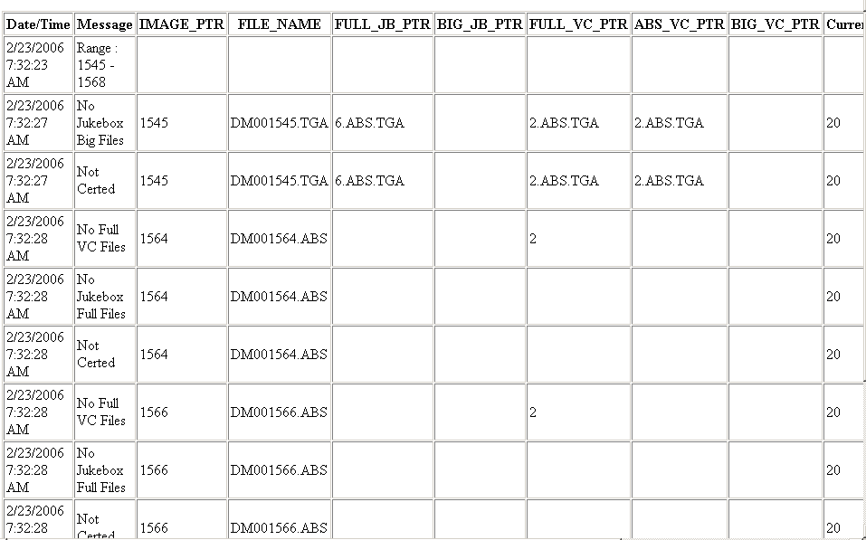
Figure 13 Scanerror.html

Date/Time | Actual time when the IMAGE file (#2005) was processed.
Message | Description of action taken.
IMAGE_PTR | IMAGE file (#2005) currently being processed.
FILE_NAME | Filename (FILEREF) in the current IMAGE file (#2005) record being processed.
FULL_JB_PTR | NETWORK LOCATION file (#2005.2) of jukebox where FULL image is located. Other extensions will be listed here except the BIG file. (It is listed in the JB Big column.)
BIG_JB_PTR | NETWORK LOCATION file (#2005.2) of jukebox where BIG image is located. The extensions of all files on the jukebox will be listed.
FULL_VC_PTR | NETWORK LOCATION file (#2005.2) of image share where FULL image is located. (Other file extensions that are on this share are listed, also.)
ABS_VC_PTR | NETWORK LOCATION file (#2005.2) of image share where abstract image is located. (Other file extensions that are on this share are listed, also.)
BIG_VC_PTR | NETWORK LOCATION file (#2005.2) of image share where the BIG image is located.
Current_Write_PTR | Image share that is the current write location. This will change automatically if the AUTO WRITE LOCATION UPDATE option is selected. (The check is done after 100 writes to the share or 20 minutes has expired since the last check.)
Table 12 Scanerror.html

2.3.2.5 DFNError.html
The DFNError.html file (Figure 14) displays patient integrity issues. The Memo column messages are described in Appendix C. Call the National Help Desk for assistance in fixing any of these issues.
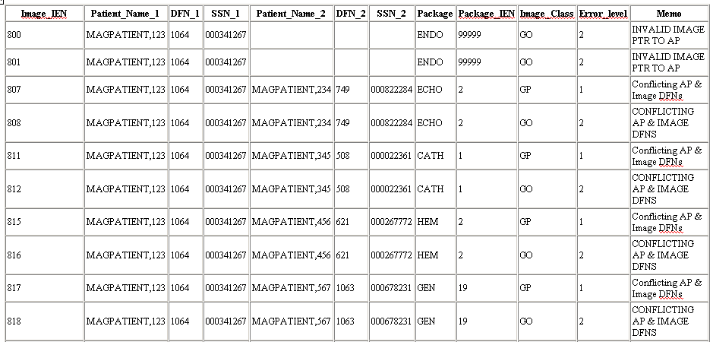
Figure 14 DFNError.log

Appendix

Appendix A Verifier Start/Run Errors
The following table lists the errors that may occur when the Verifier encounters a problem when it is started or while it is running.

Error Message | Explanation
About to exit without processing: 0 | There were no IMAGE AUDIT file (#2005.1) and OFFLINE IMAGES file (#2006.033) records within the Range.
Broker Connection to server could not be established! | VistA RPC Broker is not currently in a listening state OR the application has timed out.  Close the application and restart.  Check with the VistA system manager for the status of the Broker listener.
CC:createcontext  ("MAG WINDOWS") could not be established! | The user does not have the MAG WINDOWS menu option assigned. A user must have this option to run the Verifier.
lbCacheShare.items.Count < 1: MAGQ SHARES | There are no online, non-router VMC shares.  Use the Background Processor’s Network Location Management utility to resolve.
Invalid Input Range | The Start and Stop values entered in the Range are not correct (e.g. Start: 0 End: 0).
Jukebox shares are not setup | The jukebox share(s) are offline or don’t exist in the NETWORK LOCATION file (#2005.2).
This workstation is not currently setup as a Background Processor. | You must use the option Add/Remove BP Workstations on the Queue Processor to add this workstation to the WORKSTATIONS file (#2006.8) in VistA.
Verifier client software is version nnn. VistA Imaging Host software is version mmm. Please update to compatible client and host software. Shutting down Verifier... | The version of the KIDS file installed on VistA does not match the executable version on the workstation.
VistA Cache shares are not setup | The image share(s) are offline or don’t exist in the NETWORK LOCATION file (#2005.2).

Appendix B Output HTML Messages

Message | Explanation
Aggregate JB Copy Error: | Could not copy from alternate jukebox to current jukebox
Abs to JB: | Abstract has been created and copied to the jukebox
Aggregate Function - Disabled | Software is not enabled to copy files from secondary jukebox
Aggregate Function - Enabled | Software is enabled to copy files from secondary jukebox,  if necessary
BIG Aggregate Failed | Could not copy BIG file from secondary jukebox
Create Process failed | Could not create process on VistA for Verifier
Empty FBIG node | "FBIG" node has no pointers set in 2005 record.
File of size zero created then deleted | Abstract file created of size zero. Then it is deleted.  (Likely corruption of BIG and/or TGA file)
FULL Aggregate Failed | Could not copy FULL file from secondary jukebox
FULL Aggregate Failed | Could not copy FULL file from secondary jukebox
Images JB share is OFF-LINE: | Jukebox is offline
Make AbstractError | Abstract file could not be created from TGA/BIG  (BIG/TGA not found or image file corruption).
New Abs to CWL | An abstract file has been created and copied to the current write image share
No ABS file VC Ptr Cleared | Abstract file not found on the Image share
No ABS file VC Share OFF-Line | Image share is offline at location of abstract file
No ABS JB Files | No abstract file found on the jukebox
No Acquisition Site in Image file | The ACQUISITION SITE field #100 in the Imaging file (#2005) is missing. This is a required field.
No FULL JB Files | FULL file not found on the jukebox
No FULL VC Files | FULL file not found on the Image share
No Jukebox BIG Files | BIG file not found on the jukebox
No Jukebox FULL Files | FULL file not found on the jukebox
No Network References | No 2005 record exists for this image
No Network References: Archived Image | Image has been archived (resides in 2005.1)
No VC BIG Files | Could not find the BIG file on the image share
Not Certed | Could not find/create file type on jukebox
Problem rename log file: | Permission problem with log file
Text file Patient ID not in VistA | Could not locate patient ID in VistA
TXT to BIG VC | Copy TXT file to same share as BIG file
TXT to FULL VC | Copy TXT file to same share as FULL file
"Check Text" Option Messages
Text File Corruption Error Type 1: | Text file is binary or unreadable
Cannot determine Text file type: | Foreign text file was not likely generated on the image  gateway
Text File Corruption Error Type 2: | Text file is ASCII but has unprintable characters or truncated
Text/Image DFN Mismatch: | Patient ID in text file does not match that in VistA
Text/Image SOP/UID Mismatch | The Series Instance UID in the text file does not match the  one in VistA
Text/Image Study/UID Mismatch | The Study Instance UID in the text file does not match  the one in VistA
Text/Image UID Mismatch | SOP and/or Study UID are/is blank in text file
Updated Text file | Text file has been edited
No SSN Found | Patient ID field missing in text file

Appendix C Patient Integrity Messages
The following integrity issues will prevent their respective images from being displayed and an integrity error message will be generated when the image is retrieved for viewing.
- No Image Ptr in AP
The Clinical Association Report (AP) for this image does not contain an image entry that points back to this image.
- GP has no images
Image series that does not contain any images. Group Parents (GP) are containers for an Image series. A group parent with NO group objects (GO) is an invalid condition.
- Conflicting AP & Image DFNs
The patient file reference (DFN) in the Clinical Association Report does not match the DFN in the IMAGE file (#2005).
- Invalid Image Ptr to AP
The Clinical Association Report (AP) has image references that are not in the IMAGE file (#2005).
- Conflicting GP and GO DFN
The patient file reference (DFN) in the Group Parent (GP) is not the same as the DFN in the Image entry.
- GP & GO AP Mismatch
The Group Parent and Group Object pointer references to a Clinical Association Report (AP) do not match.
- GP Missing GO Ptr
The Group Object multiple of the referenced Group Parent does not reference this group object.
- No AP Mult Ptr
This Image entry does not have the clinical application (AP) image multiple entry number specified. The IMAGE file (#2005) record is missing the PARENT DATA FILE IMAGE POINTER for a Clinical Association Report (AP).
- GO DFN mismatches
Some image file Group Objects have different PATIENT file (#2) references (DFN).
- Image entry is structurally abnormal
The normal structure that distinguishes Image entry Group Parents (GP), Group Objects (GO), and Non-Group image (NG) is corrupt.
- Missing Group Objects
The Group Parent has Group Object references that are missing.
- DFN Mismatches in AP Image Mult
The Clinical Association Report (AP) references a Group Parent that has image files with a different PATIENT file (#2) reference (DFN) than the report.

The following integrity issues will not prevent their respective images from being displayed. These are informational messages.
1) No AP Ptr
The IMAGE file (#2005) record is missing the PARENT DATA FILE# for a Clinical Association Report (AP). This Image does not have the entry in the clinical application (AP) specified.
2) No AP entry Ptr
This Image does not have the entry in the clinical application (AP) specified. The IMAGE file (#2005) record is missing the PARENT GLOBAL ROOT DO for a Clinical Association Report (AP).

Appendix D Text File Samples (with integrity problems)

Text file is binary or unreadable
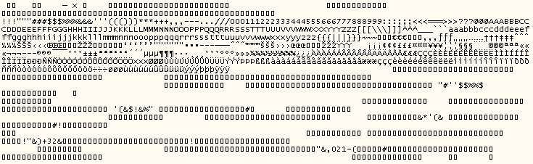
Text file

Text file is ASCII, but has unprintable characters or is truncated.
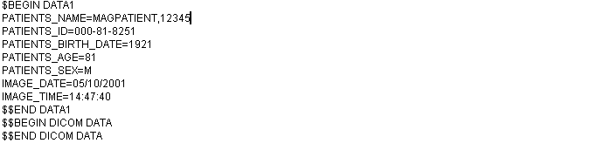
Text file

Patients ID (SSN) field in the text file does not match that in VistA.
- IEN for this sample is 1800
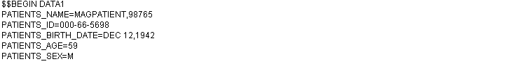
Text file

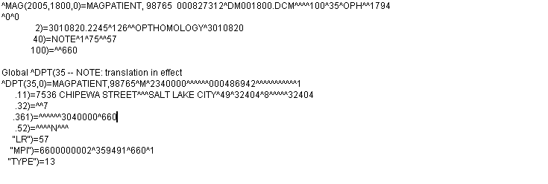
VistA Global

SOP Instance UID field in the text file does not match the one in VistA.
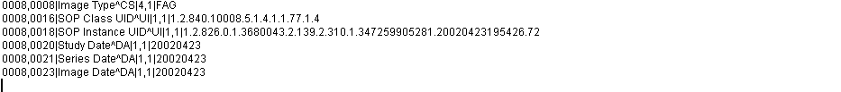
Text File

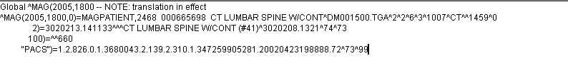
VistA Global

Study Instance UID field in the text file does not match the one in VistA.

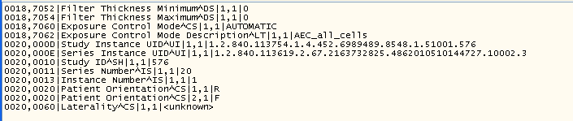
Text file

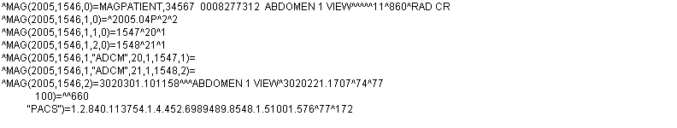
VistA Global (Note the Study Instance UID is found in the parent file)

SOP and/or Study Instance UID are/is blank in the text file.

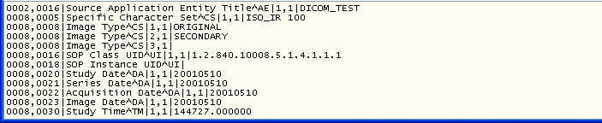
Text file

Patients ID (SSN) in the top section (DATA1) of the text file does not match DICOM- 0010,0020 field in the bottom section (DICOM DATA).
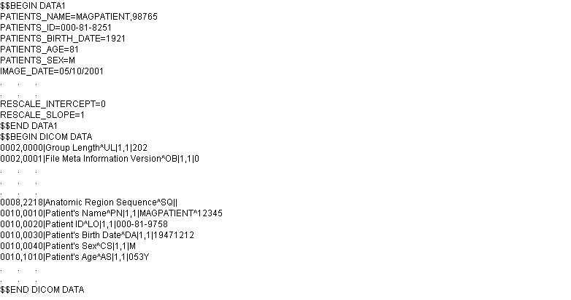
Text file

Glossary
Associated File Report | Includes Radiology reports, TUI notes, etc…
Auto Write Update | The Image share with the most amount of free space becomes the current write location. The check for space is made after 100 writes to the Image shares or after 20 minutes (whichever comes first).
Critical low message | A notification sent through e-mail to alert users that an Image share free space has fallen below the %Server Reserve watermark.
Current write location (CWL) | All images are currently being saved to this Image share.
DFN | Internal Entry Number of PATIENT file (#2) in VistA.
DICOM | Digital Imaging and Communications in Medicine.
Directory Hashing | Process of storing files in multiple subdirectories based on the filename.
IEN | Internal Entry Number.
Image Set | Includes the FULL/ABS/TXT files and possibly the BIG file.
UNC | Universal Naming Convention indicated by the format \\SERVER\SHARENAME.

